Ukulele Songbook

Vol 1

Page

1. American Pie – Don McLean

3. Cecilia – Simon and Garfunkel

5. Comfortably Numb – Pink Floyd

7. Creep – Radiohead

8. Edelweiss – Rogers & Hammerstein, The Sound of Music

9. Desperado – Johnny Cash

11. Lonestar – Norah Jones

12. For Emily Whenever I May Find Her – Simon and Garfunkel

13. Homeward Bound – Simon and Garfunkel

15. Margaritaville – Jimmy Buffet

17. Last Dance with Maryjane – Tom Petty

19. Nothing Else Matters – Metallica



21. Sound of Silence – Simon and Garfunkel

23. Staring at the Sun – U2

25. The Boxer – Simon and Garfunkel

27. Boys of Summer – Don Henley

29. The Hounds of Winter – Sting

31. USS Make Shit Up – Voltaire

33. When I Come Around – Green Day

35. Fireflies – Owl City

37. Hurt – Johnny Cash

v 1.3

**American Pie – Don McLean**

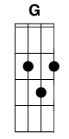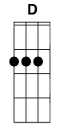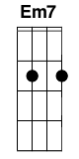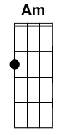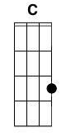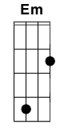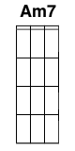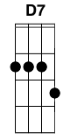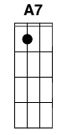

**G D Em7**

A long, long time ago,

**Am C Em D**

I can still remember how that music used to make me smile

**G D Em7**

And I know if I had my chance,

**Am C Em C D**

That I could make those people dance and maybe they'd be happy for a while

**Em Am Em Am**

But February made me shiver, with every paper I'd deliver

**C G Am C D**

Bad news on the doorstep, I couldn't take one more step

**G D Em Am7 D**

I can't remember if I cried when I read about his widowed bride

**G D Em**

Something touched me deep inside

**C D7 G C G**

The day the music died

CHORUS:

**G C G D**

So bye, bye Miss American Pie

**G C G D**

Drove my Chevy to the levy but the levy was dry

**G C G D**

And them good old boys were drinkin' whiskey and rye

**Em A7 Em D7**

Singin' this will be the day that I die, this will be the day that I die

**G Am**

Did you write the book of love

**C Am Em D**

And do you have faith in god above, if the bible tells you so?

**G D Em**

Do you believe in rock and roll

**Am7 C Em A7 D**

Can music save your mortal soul and can you teach me how to dance real slow?

**Em D Em D**

Well I know that you're in love with him 'cuz I saw you dancin' in the gym

**C G A7 C D7**

You both kicked off your shoes, man I dig those rhythm and blues

**G D Em Am C**

I was a lonely teenage broncin' buck with a pink carnation and a pickup truck

**G D Em C D7 G C G**

But I knew I was out of luck the day the music died, I started singin'

*CHORUS*

**G Am**

Now for ten years we've been on our own,

**C Am Em D**

and moss grows fat on a rolling stone but that's not how it used to be

**G D Em**

When the jester sang for the king and queen

**Am7 C Em A7 D**

in a coat he borrowed from James Dean in a voice that came from you and me

**Em D Em D**

And while the king was looking down, the jester stole his thorny crown

**C G A7 C D7**

The courtroom was adjourned, no verdict was returned

**G D Em Am C**

And while Lenon read a book on Marx, the quartet practiced in the park

**G D Em C D7 G C G**

And we sang dirges in the dark the day the music died, we were singin'

*CHORUS*

Helter skelter in a summer swelter

the birds flew off with a fallout shelter, eight miles high and fallin' fast

It landed foul on the grass

the players tried for a forward pass, with the jester on the sidelines in a cast

Now at halftime there was sweet perfume, while sergeants played a marching tune

We all got up to dance, but we never got the chance

'Cuz the players tried to take the field, the marching band refused to yield

Do you recall what was revealed the day the music died, we started singin'

*CHORUS*

And there we were all in one place,

a generation lost in space, with no time left to start again

So come on Jack be nimble, Jack be quick,

Jack Flash sat on a candle stick, 'cuz fire is the devil's only friend

And as I watched him on the stage, my hands were clenched in fists of rage

No angel born in Hell could break that Satan's spell

And as the flames climbed high into the night to light the sacrificial rite

I saw Satan laughing with delight the day the music died, he was singin'

*CHORUS*

**G D Em**

I met a girl who sang the blues

**Am C Em D**

And I asked her for some happy news, but she just smiled and turned away

**G D Em**

I went down to the sacred store

**Am C Em C**

Where I'd heard the music years before, but the man there said the music **D**

wouldn't play

**Em Am Em Am**

But in the streets the children screamed, the lovers cried and the poets dreamed

**C G Am C D**

But not a word was spoken, the church bells all were broken **G D Em Am7 C D7**

And the three men I admire most, the Father, Son, and the Holy Ghost

**G** **D Em Am7 D7 G**

They caught the last train for the coast the day the music died,

**D7**

And they were singin'

FINAL CHORUS:

So bye, bye Miss American Pie

Drove my Chevy to the levy but the levy was dry

And them good old boys were drinkin' whiskey and rye

**C D7 G C G**

Singin' this will be the day that I die.

**Cecilia – Simon and Garfunkel**

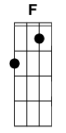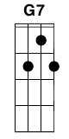

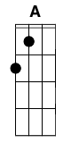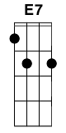

**CA FD CA**

Celia, you re breaking my heart

**FD CA G7E7**

You're shaking my confidence daily

**FD CA FD CA**

Oh, Cecilia, I'm down on my knees

**FD CA G7E7**

I'm begging you please to come home

**CA FD CA**

Celia, you're breaking my heart

**FD CA G7E7**

You're shaking my confidence daily

**FD CA FD CA**

Oh, Cecilia, I'm down on my knees

**FD CA G7E7**

I'm begging you please to come home

**CA**

Come on home

**CA FD CA**

Making love in the afternoon with Cecilia

**FD G7E7 CA**

Up in my bedroom (making love)

**FD CA**

I got up to wash my face

**FD**

When I come back to bed

**G7E7 CA**

Someone’s taken my place

**CA FD CA**

Celia, you're breaking my heart

**FD CA G7E7**

You're shaking my confidence daily

**FD CA FD CA**

Oh, Cecilia, I'm down on my knees

**FD CA G7E7**

I'm begging you please to come home

**CA**

Come on home

**FD CA FD CA G7E7**

Whooooooooooooooo

**CA FD CA**

**FD CA G7E7**

**FD CA FD CA**

**FD CA G7E7**

**FD CA FD CA**

Jubilation, she loves me again,

**FD CA G7E7**

I fall on the floor and I laughing,

**FD CA FD CA**

Jubilation, she loves me again,

**FD CA G7E7**

I fall on the floor and I laughing

**FD CA FD CA FD CA G7E7**

Whoooooooooooooooooooooooo 4x

**Comfortably Numb – Pink Floyd**

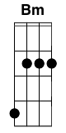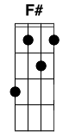

**Bm**

Hello

**A**

Is there anybody in there ?

**G Em**

Just nod if you can hear me

**Bm**

Is there anyone at home ?

**Bm**

Come on now

**A**

I hear your feeling down

**G (F#) Em**

I can ease your pain

**Bm**

And get you on your feet again

**Bm**

Relax

**A**

I'll need some information first

**G (F#) Em**

Just the basic facts

**Bm**

Can you show me where it hurts?

**D A**

There is no pain you are receding

**D A**

**A** distant ship smoke on the horizon

**C G**

You are only coming through in waves

**C G**

Your lips move but I can't hear what you're saying

**D A**

When I was a child I had a fever

**D A**

My hands felt just like two ballons

**C G**

Now I've got that feeling once again

**C**

I can't explain, you would not understand

**G**

This is not how I am

**A Bm C (9 fr.) G D**

I___________ have become comfortably numb.

**A D A C G C G**

**A C G D**

I_____ have become comfortably numb.

**Bm**

O.K.

**A**

Just a little pinprick

**G Em**

There'll be no more aaaaaaaah!

**Bm**

But you may feel a little sick

**Bm Bm(9) Bm**

Can you stand up?

**A**

I do believe it's working, good

**G**

That'll keep you going through the show

**Bm**

Come on it's time to go.

**D** **A**

There is no pain, you are receding

**D** **A**

A distant ship smoke on the horizon

**C** **G**

You are only coming through in waves

**C G**

Your lips move but I can't hear what you're saying

**D A**

When I was a child, I caught a fleeting glimpse

**D A**

Out of the corner of my eye

**C G**

I turned to look but it was gone

**C**

I cannot put my finger on it now

The child is grown

**G**

The dream is gone

**Asus4 A G C (9 fr.) G D**

And I________ have become comfortably numb.

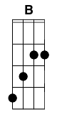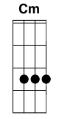**Creep – Radiohead**

**G**

When you were here before

**B**

Couldn't look you in the eyes

**C**

You look like an angel

**Cm**

Your skin makes me cry

**G**

You float like a feather

**B**

In a beautiful world

**C**

I wish I was special

**Cm**

You're so fucking special

*Chorus:*

**G**

But I'm a creep

**B**

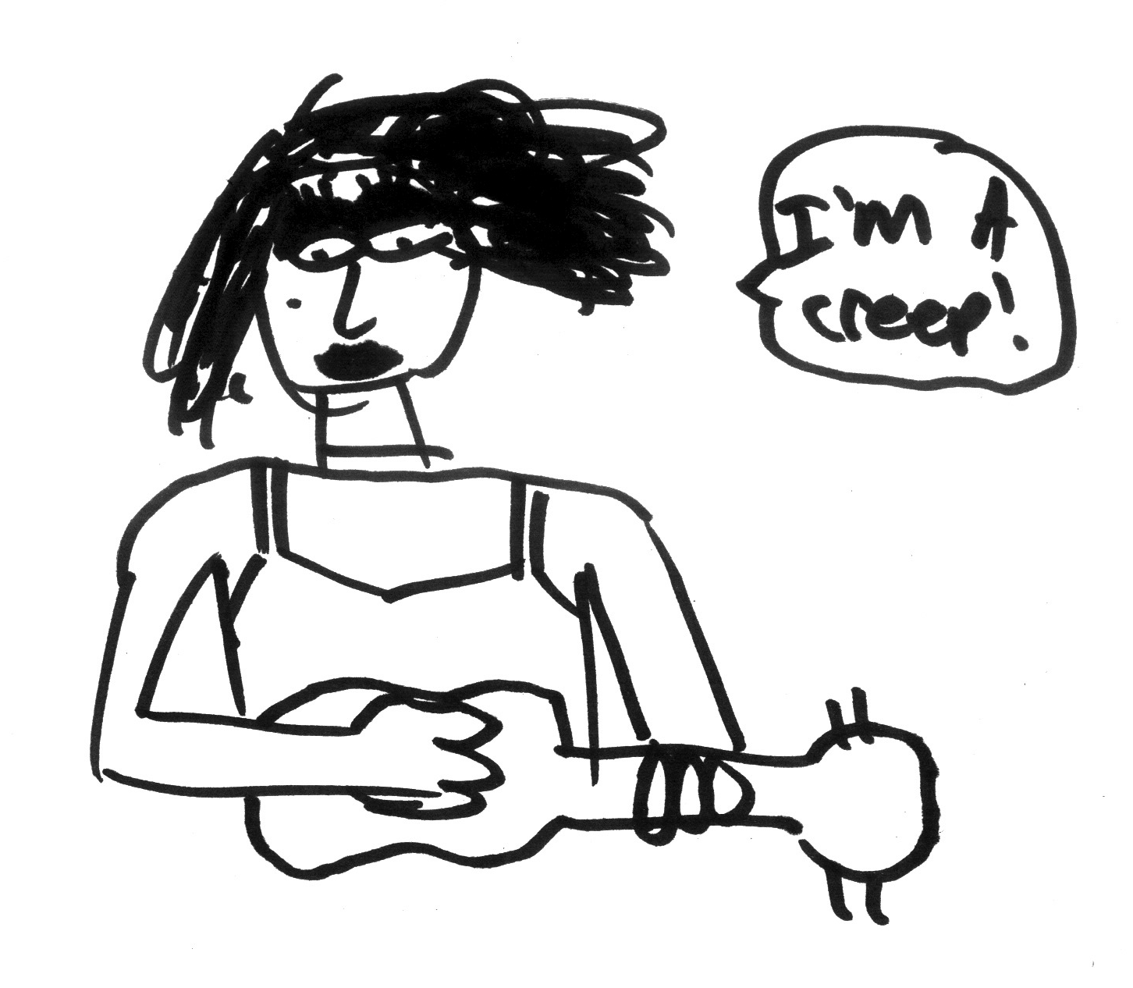I'm a wierdo

**C**

What the hell am I doin' here

**Cm**

I don't belong here

*Verse 2:*

I don't care if it hurts

I wanna have control

I wanna perfect body

I want a perfect soul

I want you to notice

When I'm not around

You're so fuckin' special

I wish I was special....

Shes runnin out.. again....

She's Runnin out, Run, Run, Run oooooohhhh

Oooohhhh, ooohhhh ohhhhhh

Whatever makes you happy

Whatever you want

You're so fucking special

Wish I was special...

**Edelweiss – The Sound of Music**



**G DD7 G C**

Edelweiss, edelweiss

**G Em Am7 D7**

Every morning you greet me

**G DD7 G C**

Small and white, clean and bright

**G D7 G**

You look happy to meet me

**DD7 G**

Blossom of snow may you bloom and grow

**C A7 D D7**

Bloom and grow, forever

**G DD7 G C**

Edelweiss, edelweiss

**G D7 C G**

Bless my homeland forever

**Desperado – Johnny Cash**



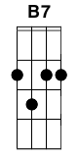****

**G G7 C Cm**

Desperado, why don't you come to your senses?

**G Em7 A7 D7**

You been out ridin' fences for so long now

**G G7 C**

Oh, you're a hard one, but I know that you've got your

**Cm**

reasons,

**G B7 Em7 A7 D7 G**

These things that are pleasin' you can hurt you somehow

**D Em Bm**

Don't you draw the queen of diamonds boy,

**C G**

She'll beat you if she's able,

**Em7 C G D**

**K**now the queen of hearts is always your best bet

**Em Bm C**

Now it seems to me some fine things have been laid upon

**G**

your table

**Em A7 Am7 D D7**

But you only want the things that you can't get

**G G7 C Cm**

Desperado, oh you ain't gettin' no younger,

**G Em7 A7 D7**

Your pain and your hunger, they're drivin' you home

**G G7 C**

And freedom, oh freedom, well, that's just some people

**Cm**

talkin'

**G B7 Em7 A7 D7 G**

Your prison is walkin' through this world all alone

**D Em Bm**

Don't your feet get cold in the winter time?

**C G**

The sky won't snow and the sun won't shine

**Em7 C G D**

It's hard to tell the night time from the day

**Em Bm**

You're losin' all your highs and lows

**C G Am7 D D7**

Ain't it funny how the feelin' goes away

**G G7 C Cm**

Desperado, why don't you come to your senses

**G D Em A7 D7**

Come down from your fences, open the gate

**G G7 C Cm**

It may be rainin', but there's a rainbow above you

**G B7 Em C G**

You better let somebody love you, you better let somebody

**Am7**

love you

**G B7 Em Am7 D7 G**

You better let somebody love you before it's too late

**Lonestar – Norah Jones**

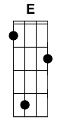



**Intro:  / CD - / - - /**

**CD        FG         CD**

Lonestar, where are you out tonight?

**GA           EF#       AmBm  Am7Bm7 D7E7**  
This feeling I'm trying to fight  
**GA            EF#       AmBm Am7Bm7D7E7**

It's dark and I think that I     would give anything

**FG          GA         CD**  
For you to shine down on me

**CD       FG       CD**

How far you are I just don't know

**GA           EF#        AmBm Am7Bm7 D7E7**  
The distance I'm willing to go

**GA        EF#        AmBmAm7Bm7 D7E7**  
I pick up a stone that I cast to the sky  
**FG          GA           CD**

Hoping for some kind of sign

**CD        FG        CD**

Lonestar, where are you out tonight?

**GA           EF#       AmBmAm7Bm7 D7E7**  
This feeling I'm trying to fight  
**GA          EF#      AmBmAm7Bm7     D7E7**

It's dark and i think that I   would give anything

**FG         GA          AmBmAm7Bm7   D7E7**  
For you to shine down on me

**FG(hold)    GA(hold)     CD (hold)**  
For you to shine down on me

**For Emily Whenever I May Find Her – Simon and Garfunkel**

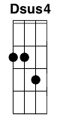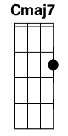

**D**

What a dream I had

**G Em**

Pressed in organdy

**D**

Clothed in crinoline

**Cmj7**

Of smoky burgundy

**G A**

Softer than the rain

**D**

I wandered empty streets down

**G Em**

Past the shop displays

**D**

I heard cathedral bells

**Cmj7**

Dripping down the alleyways

**G A**

As I walked on

**D**

And when you ran to me, your

**G Em**

Cheeks flushed with the night

**D**

We walked on frosted fields

**Cmj7**

Of juniper and lamplight

**G A**

I held your hand

**D**

And when I awoke

**G Em**

And felt you warm and near

**D**

I kissed your honey hair

**Cmj7**

With my grateful tears

**G A**

Oh, I love you girl

**Cmj7 G A Dsus4**

Oh, I love you

**Homeward Bound – Simon and Garfunkel**

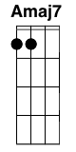

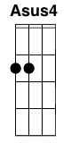

**A**

I'm sitting in the railway station.

**Amaj7 A7 F#**

Got a ticket for my destination, mmmm

**Bm G**

On a tour of one-night stands my suitcase and guitar in hand.

**A E7 A**

And ev'ry stop is neatly planned for a poet and one-man band.

**D A**

Homeward bound, wish I was,

**D**

Homeward bound,

**A Asus4**

Home where my thought's escaping

**A Asus4**

Home where my music's playing,

**A Asus4**

Home where my love lays waiting

**E A**

Silently for me.

**A**

Ev'ry day's an endless stream

**Amaj7 A7 F#**

Of cigarettes and magazines, mmmm

**Bm G**

And each town looks the same to me, the movies and the factories

**A E7 A**

And ev'ry stranger's face I see reminds me that I long to be,

**D A**

Homeward bound, wish I was,

**D**

Homeward bound,

**A Asus4**

Home where my thought's escaping

**A Asus4**

Home where my music's playing,

**A Asus4**

Home where my love lays waiting

**E A**

Silently for me.

**A**

Tonight I'll sing my songs again,

**Amaj7 A7 F#**

I'll play the game and pretend, mmmm

**Bm G**

But all my words come back to me in shades of mediocrity

**A E7 A**

Like emptiness in harmony I need someone to comfort me.

**D A**

Homeward bound, wish I was,

**D**

Homeward bound,

**A Asus4**

Home where my thought's escaping

**A Asus4**

Home where my music's playing,

**A Asus4**

Home where my love lays waiting

**E A**

Silently for me.

**Amaj7 A7 A**

Silently for me.

**Margaritaville – Jimmy Buffet**

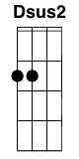

DDU-UDU 121bpm

**Intro (w/intro riff):**

A|-------------------------------------0-|

E|-2-2-2-0-2---2-2-2-0-2---4-4-4-2-0---2-|

C|-------------------------------------2-|

G|-2-2-2-0-2---2—2-2-0-2---5-5-5-2-0---2-|

**/ D – Dsus2 D / D – Dsus2 D /**

**/ G - - A / D - - - / - - - - /**

**D (6)**

Nibblin’ on sponge cake  
Watchin’ the sun bake

**A (8)**All of those tourists covered with oil  
Strummin’ my six-string  
On my front porch swing

**D     D7**Smell those shrimp they’re beginnin’ to boil  
  
Chorus:

**G        A                D         D7**Wastin’ away again in margaritaville

**G                 A              D   D7**Searching for my lost shaker of salt

**G            A                   D (½)  A (½)    G**Some people claim that there’s a wo  -  man to blame

**A (2)**But I know

**D (2)**

it’s nobody’s fault

**D (6)**I don’t know the reason  
I stayed here all season

**A (8)**Nothin’ to show but this brand new tattoo  
But it’s a real beauty  
**A** Mexican cutie

**D   D7**How it got here I haven’t a clue

Chorus 2:

**G         A                D         D7**Wastin’ away again in margaritaville

**G                 A               D   D7**Searching for my lost shaker of salt

**G             A                  D (½)  A (½)    G**Some people claim that there’s a wo  -  man to blame

**A (2)**now I think

**D (2)**

Hell, it could be my fault

**D (6)**I blew out my flip-flop  
Stepped on a pop-top

**A (8)**Cut my heel had to cruise on back home  
But there’s booze in the blender  
And soon it will render

**D   D7**That frozen concoction that helps me hang on

Chorus 3:

**G        A                D         D7**Wastin’ away again in margaritaville

**G                 A              D   D7**Searching for my lost shaker of salt

**G            A                   D (½)  A (½)    G**Some people claim that there’s a wo  -  man to blame

**A (2)**but I know

**D (2)**

it’s my own damn fault

**G             A                  D (½)  A (½)    G**Some people claim that there’s a wo  -  man to blame

**A (2)**but I know

**D (2)**

it’s my own damn fault

*Repeat Intro*

**Last Dance With Maryjane – Tom Petty**



**Intro:** **Am** *(hammer on index finger)* **G D Am**

**Verse 1:**

**Am G**

She grew up in an Indiana town

**D Am**

Had a good lookin' momma who never was around

**Am G**

But she grew up tall and she grew up right

**D Am**

With them Indiana boys on an Indiana night

**Am G**

Well she moved down here at the age of 18

**D Am**

She blew the boys away, it was more than they'd seen

**Am G**

I was introduced and we both started groovin'

**D Am**

She said, "I dig you baby but I got to keep movin'"

...on, keep movin' on

**Chorus:**

**D**

Last dance with Mary Jane

**A**

One more time to kill the flame

**D**

I feel summer creepin' in and I'm

**A**

Tired of this town again

**Am | G ||| D ||| Am |**

*(try "|" for strumming method)*

**Verse 2:**

Well I don't know but I've been told

You never slow down, you never grow old

I'm tired of screwing up, I'm tired of bein' down

I'm tired of myself, I'm tired of this town

Oh my my, oh hell yes

Honey put on that party dress

Buy me a drink, sing me a song,

Take me as I come 'cause I can't stay long

Chorus:

**D**

Last dance with Mary Jane

**A**

One more time to kill the flame

**D**

I feel summer creepin' in and I'm

**A**

Tired of this town again

**Verse 3:**

There's pidgeons down in Market Square

She's standing in her underwear

Lookin' down from a hotel room

Nightfall will be coming soon

Oh my my, oh hell yes

You've got to put on that party dress

It was too cold to cry when I woke up alone

I hit the last number, I walked to the road

**Chorus:**

**D**

Last dance with Mary Jane

**A**

One more time to kill the flame

**D**

I feel summer creepin' in and I'm

**A**

Tired of this town again

**Nothing Else Matters – Metallica**

Intro: **EmAm**...

**EmAm - EmAm - DG - CF**

**EmAm DG CF**

So close no matter how far

**EmAm DG CF**

couldnt be much more from the heart

**EmAm DG CF**

forever trusting who we are

**GC B7E7  EmAm**

and nothing else matters

**EmAm DG CF**

never opened myself this way

**EmAm DG CF**

life is ours, we live it our way

**EmAm DG CF**

all these words I don't just say

**GC B7E7 EmAm**

and nothing else matters

**EmAm DG CF**

trust I seek and I find in you

**EmAm DG CF**

every day for us something new

**EmAm DG CF**

open mind for a different view

**GC B7E7 EmAm CF AD**

and nothing else matters

**DGCFAD**

*never cared for what they do*

**DGCFAD**

*never cared for what they know*

**DGEmAm**

*but I know*

**EmAm DG CF**

So close no matter how far

**EmAm DG CF**

couldnt be much more from the heart

**EmAm DG CF**

forever trusting who we are

**GC B7E7 EmAm**

and nothing else matters

**DGCFAD**

*never cared for what they do*

**DGCFAD**

*never cared for what they know*

**DGEmAm**

*but I know*

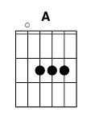**EmAm DG CF**

never opened myself this way

**EmAm DG CF**

life is ours, we live it our way

**EmAm DG CF**

all these words I don't just say

**GC B7E7  EmAm**

and nothing else matters

**EmAm DG CF**

trust I seek and I find in you

**EmAm DG CF**

every day for us something new

**EmAm DG CF**

open mind for a different view

**GC B7E7 EmAm CF AD**

and nothing else matters

**DG CF AD**

never cared for what they say

**DG CF AD**

never cared for games they play

**DG CF AD**

never cared for what they do

**DG CF AD**

never cared for what they know

**DG EmAm**

and I know

**EmAm DG CF**

So close no matter how far

**EmAm DG CF**

couldnt be much more from the heart

**EmAm DG CF**

forever trusting who we are

**GC B7E7 EmAm**

no nothing else matters

**Sound of Silence – Simon and Garfunkel**



**Am G**

Hello darkness, my old friend,

**Am**

I've come to talk with you again,

**F C**

Because a vision softly creeping,

**F C**

Left it's seeds while I was sleeping,

**F C**

And the vision that was planted in my brain

**Am**

Still remains

**G Am**

Within the sound of silence.

**G**

In restless dreams I walked alone

**Am**

Narrow streets of cobblestone,

**F C**

'neath the halo of a street lamp,

**F C**

I turned my collar to the cold and damp

**F C**

When my eyes were stabbed by the flash of a neon light **Am**

That split the night

**G Am**

And touched the sound of silence.

**G**

And in the naked light I saw

**Am**

Ten thousand people, maybe more.

**F C**

People talking without speaking,

**F C**

People hearing without listening,

**F** **C**

People writing songs that voices never share

**Am**

And no one dare

**G Am**

Disturb the sound of silence.

**G**

Fools said ah, you do not know

**Am**

Silence like a cancer grows.

**F C**

Hear my words that I might teach you,

**F C**

Take my arms that I might reach you.

**F C**

But my words like silent raindrops fell,

And echoed

**G Am**

In the wells of silence

**G**

And the people bowed and prayed

**Am**

To the neon God they made.

**F C**

And the sign flashed out it's warning,

**F C**

In the words that it was forming.

**F**

And the sign said, the words of the prophets

**Am C**

Are written on the subway walls

**C**

And tenement halls.

**Am G Am**

And whisper'd in the sounds of silence.

/ /

*Picking, here to here*

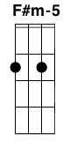**Staring At The Sun – U2**

**Intro: Am,G,F,Em x3**

**Verse 1:**

**Am G**

Summer stretching on the grass

**F Em**

Summer dresses pass

**Am G**

In the shade of a willow tree

**F Em**

Creeps a crawling over me

**Am G**

Over me and over you

**F Em**

Stuck together with God`s glue

**Am G**

It`s going to get stickier too

**F**

It`s been a long hot summer

**F#m-5**

Let`s get under the covers

**F**

Don`t try too hard to think

**G**

Don`t think at all

**C**

I`m not the only one

**Am**

Starin` at the sun

**F**

Afraid of what you`d find

**G**

If you took a look inside

**C**

Not just deaf and dumb

**Am**

Staring at the sun

**F**

Not the only one

**G**

Who`s happy to go blind

**Am, D x2**

**Verse 2:**

There`s an insect in your ear

If you scratch it won`t disappear

It`s gonna itch and burn and sting

Do you want to see what the scratching brings

Waves that leave me out of reach

Breaking on your back like a beach

Will we ever live in peace?

`Cause those that can`t do often have to

Those that can`t do often have to preach

**Chorus:**

To the ones staring at the sun

Afraid of what you`d find

If you took a look inside

Not just deaf and dumb Staring at the sun

I`m not the only one

Who`s happy to go blind

**Verse 3:**

Intransigence is all around

Military still in town

Armour plated suits and ties

Daddy just won`t say goodbye

Referee won`t blow the whistle

God is good but will he listen

I`m nearly great

But there`s something I`m missing

I left in the duty free

Though you never really belonged to me

**Chorus:**

You`re not the only one

Starin` at the sun

Afraid of what you`d find

If you stepped back inside

I`m not sucking my thumb

I`m staring at the sun

Not the only one

Who’s happy to go blind

**F F#m-5**

Ah ah I

Ah ah I

Ah ah I

Ah ah I

**The Boxer – Simon and Garfunkel**



**C Am**

I am just a poor boy, though my story’s seldom told

**G G7**

I have squandered my resistance for a pocketful of mumbles,

**C**

such are promises

**Am G F**

All lies and jest, still a man hears what he wants to hear

**C G G7 G C**

and disregards rest.

**C Am**

When I left my home and my family, I was no more than a boy

**G G7 G**

In the company of strangers, in the quiet of a railway

**C**

station, running scared

**Am G**

Laying low, seeking out the poorer quarters where the ragged

**C**

people go

**G F G G7 C**

Looking for the places only they would know.

**Am**

Lie-la-lie,

**G**

Lie-la-lie la lie-la-lie,

**Am**

Lie-la-lie

**G C**

Lie-la-lie, la la la la lie, la la la la lie.

**C Am**

Asking only workman’s wages, I come looking for a job

**G**

But I get no offers,

**G7 G C**

just a come-on from the whores on 7th Avenue

**Am G F**

I do declare there were times when I was so lonesome,

**C G G7 G C**

I took some comfort there

Ooh la la, la la la la.

**C Am G C Am G F C**

**Am**

Lie-la-lie,

**G**

Lie-la-lie la lie-la-lie,

**Am**

Lie-la-lie

**G C**

Lie-la-lie, la la la la lie, la la la la lie.

**C Am**

And I’m laying out my winter clothes and wishing I was gone

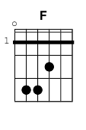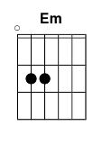 **G G7**

Going home, where the New York City winters aren’t

**C G Am G**

Bleeding me, Leading me, going home.

**C Am**

In the clearing stands a boxer and a fighter by his trade

**G G7 G**

And he carries the reminders of every glove that laid him down

**C Am**

Or cut him till he cried out in his anger and his shame

**G F C**

“I am leaving, I am leaving” but the fighter still remains.

**G G7 G C**

**Am**

Lie-la-lie,

**G**

Lie-la-lie la lie-la-lie,

**Am**

Lie-la-lie

**G C**

Lie-la-lie, la la la la lie, la la la la lie.

**Boys of Summer – Don Henley**



**Em**

Nobody on the road

**Em**

Nobody on the beach

**C**

I feel it in the air

**C**

The summer's out of reach

**D**

Empty lake, empty streets

**D**

The sun goes down alone

**C**

I'm drivin' by your house

**C**

Though I know you're not at home

**G**

But I can see you-

**D**

Your brown skin shinin' in the sun

**D C**

Ydou got your hair combed back and your sunglasses on, baby **G D**

And I can tell you my love for you will still be strong

**D C**

After the boys of summer have gone

**Em**

I never will forget those nights

**Em**

wonder if it was a dream

**C**

Remember how you made me crazy?

**C**

Remember how I made you scream

**D**

Now I don't understand

**D**

what happened to our love

**C**

But babe, I'm gonna get you back

**C**

I'm gonna show you what I'm made of

I can see you-

Your brown skin shinin' in the sun

I see you walkin' real slow and you're smilin' at everyone I can tell you my love for you will still be strong

After the boys of summer have gone

**Em**

Out on the road today, I saw a DEADHEAD sticker on a Cadillac

**C**

A little voice Inside my head said,

**C**

Don't look back. You can never look back.

**D**

I thought I knew what love was

**D**

what did I know?

**C**

Those days are gone forever

**C**

I should just let them go but-

I can see you-

Your brown skin shinin' in the sun

You got that top pulled down and that radio on, baby

And I can tell you my love for you will still be strong After the boys of summer have gone

I can see you-

Your brown skin shinin' in the sun

You got that hair slicked back and those Wayfarers on, baby I can tell you my love for you will still be strong

After the boys of summer have gone

**The Hounds of Winter – Sting**

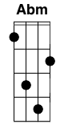



Intro: **A Abm Bm A D Bm E F#** (2x)

**A Abm**

Mercury falling

**Bm A**

I rise from my bed

**D Bm**

Collect my thoughts together

**E F#**

I have to hold my head

**A G#m**

It seems that she's gone

**Bm A**

And somehow I am pinned by

**D Bm**

The Hounds of Winter

**E F#**

Howling in the wind

I walk through the day

My coat around my ears

I look for my companion

I have to dry my tears

It seems that she's gone

Leaving me too soon

I'm as dark as December

I'm as cold as the Man in the Moon

I still see her face

As beautiful as day

It's easy to remember

Remember my love that way

All I hear is that lonesome sound

The Hounds of Winter

They follow me down

I can't make up the fire

The way that she could

I spend all my days

In the search for dry wood

Board all the windows and

close the front door

I can't believe

she won't be here anymore

I still see her face

As beautiful as day

It's easy to remember

Remember my love that way

All I hear is that lonesome sound

The Hounds of Winter

They follow me down

A season for joy

A season for sorrow

Where she's gone

I will surely, surely follow

She brightened my day

She warmed the coldest night

The Hounds of Winter

They got me in their sights

I still see her face

As beautiful as day

It's easy to remember

Remember my love that way

All I hear is that lonesome, lonesome sound

The Hounds of Winter

They harry me down

**USS Make Shit Up - Voltaire**

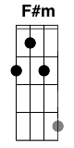

**D G D A D G A D**

*Verse 1:*

**D G**

I was stranded on a planet, just me and Spock

**D A**

we met a nasty nazi alien who locked our asses up

**D G**

We found a hunk of crystal and a metal piece of bed

**A D**

We made a laser phaser gun and shot him in the head

**D G**

I was standing on a bridge when Sulu came to me

**D A**

his eyes were full of tears he said "captain cant you see

**D G**

the ship is gonna blow do something I beseech"

**A**

I grabbed a tribble and some chewing gum and stopped the

**D**

warp core breach

*Chorus:*

and I say

**D G**

Bounce a graviton particle beam off the main deflector dish

**D A**

thats the way we do things lad We make shit up as we wish

**D G**

the klingons and the romulans pose no threat to us

**A D**

cuz if we find we're in a bind we just make some shit up

**D G F#m G A**

la, da da da, da da da, la da da da da daaa, daaa

*Verse 2:*

Although he’s just a child and something of a twit

Wesley is the master when it comes to making up some shit

he's the guy you want with you when you go out in space

if only he could beam those pimples off his face

and if you're at a party on the starship enterprise

and the karaoke player just plain old up and dies

set up an neutrino field inside a can of peas

hold on to Geordi's visor and sing into data's knee

*Chorus*

*Verse 3:*

Sisko's on a mission to go no bloody place

he loiters on the space station above Bajoran space

the wormhole opened up and now they come from near and far

we'll keep the booze but please send back the fucking Jem-hadar

What is with the Klingons, remember in the day

they looked like Puerto Ricans and they dressed in gold lamé

now they look like heavy metal rockers from the dead

with leather pants and frizzy hair and lobsters on their heads

*Chorus*

*Verse 4:*

I was stuck on Voyager and pounding on the door

when suddenly it dawned on me I've seen this show before

perhaps I'm in a warp bubble and slightly out of phase

It was way back in the sixties when they called it Lost in Space

we were looking for a way to

make the ratings soar

so we orchestrated an encounter with the Borg

normally you'd think that would get us into shit

But this one has a smashing ass and a lovely set of tits

*Chorus (End):*

and I say

Bounce a graviton particle beam off the main deflector dish

That's the way we do things lad We make shit up as we wish

the Klingons and the Romulans pose no threat to us

**A G**

cuz if we find we're in a bind we're totally screwed but nevermind

**A**

we'll pull something out of our behind...

**A D**

we’ll just make some shit up

**When I Come Around – Green Day**



**Verse 1:**

**G D Em C**

I heard you crying loud

**G D Em C**

all the way across town

**G D**

You've been searching for that someone

**Em C**

and it's me out on the prowl

**G D Em C**

As you sit around feeling sorry for yourself

**G D Em C**

Well Don't get lonely now

**G D Em C**

And Dry your whining eyes

**G D**

I'm just roaming for the moment

**Em C**

Sleazin' my back yard so don't get

**G D Em C**

so uptight you been thinking about ditching me

**Chorus:**

**Am C**

No time to search the world around.

**Am C**

Cause you know where I'll be found

When I come around

**G, D, Em, C**

**G, D, Em, C**

**Verse 2:**

**G D Em C**

I heard it all before

**G D Em C**

So don't knock down my door

**G D Em C**

I'm a loser and a user so I don't need no accuser

**G D Em C**

to try and slag me down because I know you're right

**G D Em C**

So go do what you like

**G D Em C**

Make sure you do it wise

**G D**

You may find out that your self-doubt

**Em C**

means nothing was ever there

**G D**

You can't go forcing something

**Em C**

if it's just not right

**Chorus**

**Chorus**

When I come around (3x)

**G, D, Em, C**

**Fireflies – Owl City**



**C G**

You would not believe your eyes

**Am F**

If ten million fireflies

**C G Am F**

lit up the world as I fell asleep

**C G**

'Cause they'd fill the open air

**Am F**

and leave teardrops everywhere

**C G Am F**

you'd think me rude but I'd just stand and stare

Chorus:

**Am C G**

I'd like to make myself believe

**Am C G F**

that planet Earth turns slowly

**Am G C G Am**

Its hard to say that I'd rather stay awake when I'm asleep

**Am C D**

'Cause everything is never as it seems

**C G**

'Cause I’d get a thousand hugs

**Am F**

from ten thousand lightning bugs

**C G Am F**

as they tried to teach me how to dance

**C G**

A foxtrot above my head

**Am F**

a sockhop beneath my bed

**C G Am F**

a disco ball is just hanging by a thread

*~Chorus~*

**C G**

When i fall asleep leave my door open just a crack

**Am F**

(please take me away from here)

**C G**

'Cause i feel like such an insomniac

**Am F**

(please take me away from here)

**C G**

why do i tire of counting sheep

**Am F**

(please take me away from here)

**C G Am F**

when I'm far too tired to fall asleep

To ten million fireflies

I'm weird 'cause I hate goodbyes

I got misty eyes as they said farewell

but I’ll know where several are

if my dreams get real bizarre

'cause I saved a few and I keep them in a jar

Chorus (x2)

**Am C G**

I'd like to make myself believe

**Am C G F**

that planet Earth turns slowly

**Am G C G Am**

Its hard to say that I'd rather stay awake when I'm asleep

**Am C D**

Because my dreams are bursting at the seams

**Hurt – Johnny Cash**

Intro/Verse/Transition: (fingering style)

(each chord pick first two strings, strum rest)

**Am / C / Dsus2 / Am / C / D / Am**

Verse 1:

**C Dsus2 Am C D Am**

I hurt myself today to see if I still feel

**C Dsus2 Am C D Am**

I focus on the pain the only thing that's real

**C Dsus2 Am C D Am**

The needle tears a hole the old familiar sting

**C Dsus2 Am C D *G** *(strums)*

Try to kill it all away but I remember everything

Chorus:

**Am F C G**

What have I become? My sweetest friend

**Am F C G**

Everyone I know goes away in the end

**Am F G G**

And you could have it all My empire of dirt

**Am F G - *Am** *(*fingers)*

I will let you down I will make you hurt

Instrumental transition: (see intro)

Verse 2:

**C Dsus2 Am C D Am**

I wear this crown of thorns upon my liar’s chair

**C Dsus2 Am C D Am**

Full of broken thoughts I cannot repair

**C Dsus2 Am C D Am**

Beneath the stains of time the feeling disappears

**C Dsus2 Am C D *G** *(*strums)*

You are someone else I am still right here

Chorus:

**Am F C G**

What have I become? My sweetest friend

**Am F C G**

Everyone I know goes away in the end

**Am F G G**

And you could have it all My empire of dirt

**Am F G G**

I will let you down I will make you hurt

**Am F G G**

If I could start again **A** million miles away

**Am F *G** *(*one single strum only)*

I would keep myself I would find a way

5

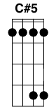 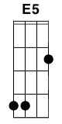 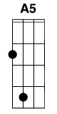 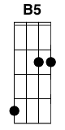

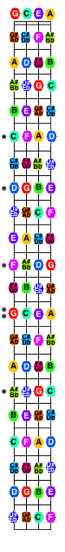6

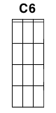 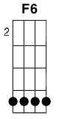 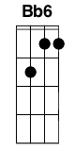

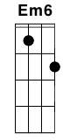 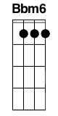

9

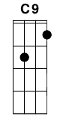 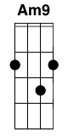

Misc

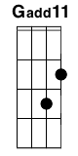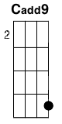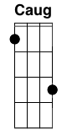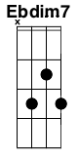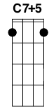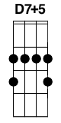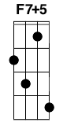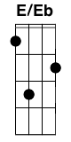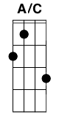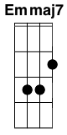

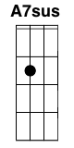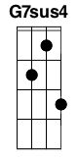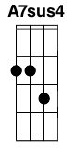

Variations

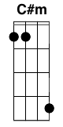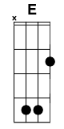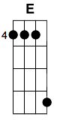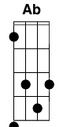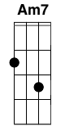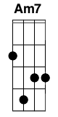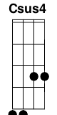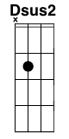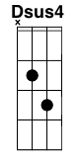

Chords – GCEA (Standard) Tuning

Maj/Minor

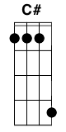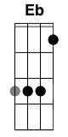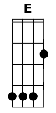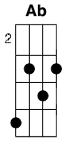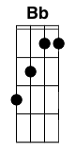

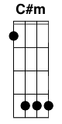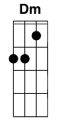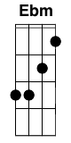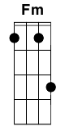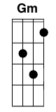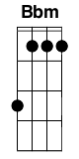

7

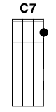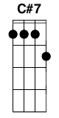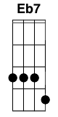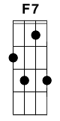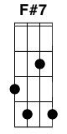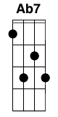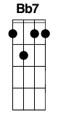

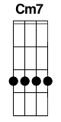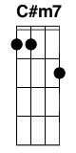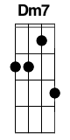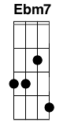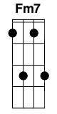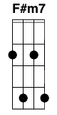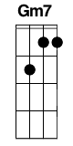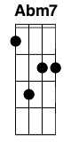****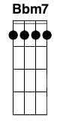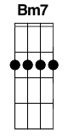

Maj

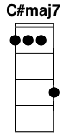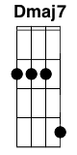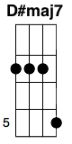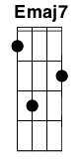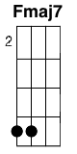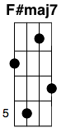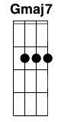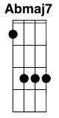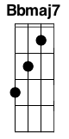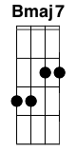

Sus

